Business Question and Visualization Report

Date | 21 September 2026
Team ID | MCA
Project Name | Strategic Employee Attrition Intelligence Dashboard
Maximum Marks | 5 Marks

Visualization development refers to the process of creating graphical representations of data to facilitate understanding, analysis, and decision-making. The goal is to transform complex datasets into visual formats that are easy to interpret, enabling users to gain insights and make informed decisions. Visualization development involves selecting appropriate visual elements, designing layouts, and using interactive features to enhance the user experience. This process is commonly associated with data visualization tools and platforms, and it plays a crucial role in business intelligence, analytics, and reporting
Business Questions and Visualisation
The process involves defining specific business questions to guide the creation of meaningful and actionable visualizations in Power BI. Well-framed questions help in identifying key metrics, selecting relevant data, and building visualisation that provide insights.
Business Questions | Visualizations | Screenshot
1. How does employee attrition rate vary across different organizational departments? | Horizontal Bar Chart showing Attrition Rate by Department. | 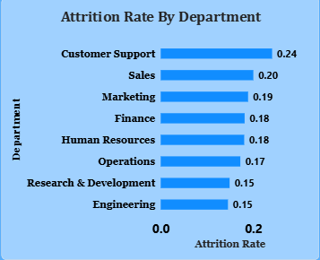
2. Which job roles face the highest rate of employee turnover? | Bar Chart showing Attrition Rate by Job Role. | 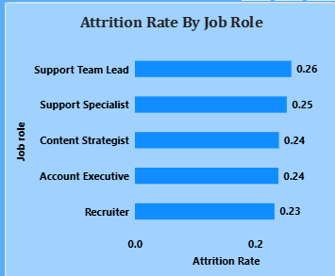
3. How does compensation growth impact employee attrition risk? | Column Chart showing Attrition Risk Across Salary Growth Bands. | 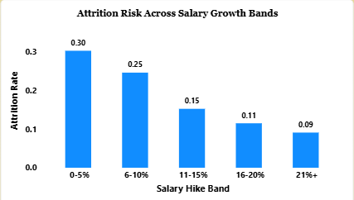
4. What is the impact of weekly overtime hours on employee attrition risk? | Horizontal Bar Chart depicting Attrition Risk by Overtime. | 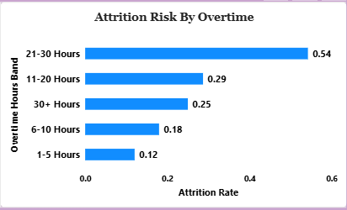
5. How does burnout severity vary across different work location models? | $100\%$ Stacked Column Chart displaying Burnout Risk Across Different Work Models (Onsite, Hybrid, Remote). | 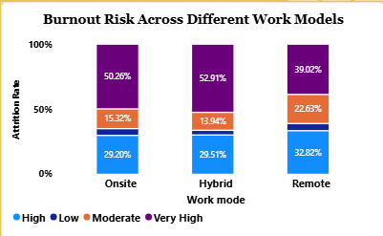
6. What is the relationship between performance ratings and employee retention? | Column Chart illustrating Attrition Risk Across Performance Level. | 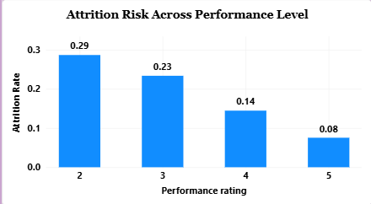
7. How does attrition risk evolve over an employee's career tenure? | Line Chart showing Employee Attrition Across Tenure Journey. | 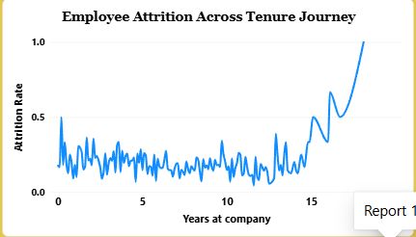
8. How is total employee headcount distributed across overall department proportions? | Donut Chart displaying Department Wise Attrition Rate & Share. | 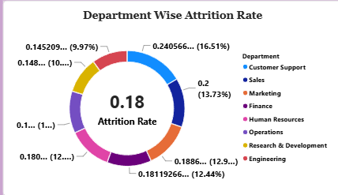
9. Does investment in employee training and development reduce turnover risk? | Line Chart depicting Attrition Risk by Training Investment across Burnout Score Bands. | 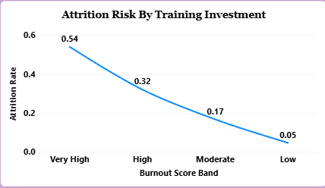
10. How does employee attrition rate vary across different career/job levels? | Line Chart showing Attrition Trends Across Career Levels. | 